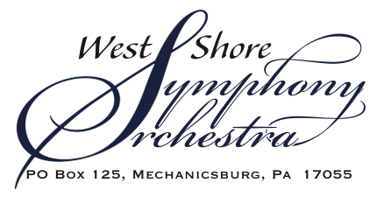

Hello,
The West Shore Symphony Orchestra (WSSO) offers an opportunity for you to become a Concert Sponsor for our 36th Anniversary Season! Under Conductor and Music Director, Dr. Jennifer Sacher Wiley, we will perform our Masterworks concerts on November 5, March 3, and May 19 and our free Family Concert on December 1 and 2, as well as free summer concerts, to be announced.
By sponsoring one or more of our concerts, you will help to ensure the ongoing success of the orchestra. Arts organizations such as WSSO depend on donors like you to continue offering affordable events to the community. Our regular season admission ticket of $15.00 allows as many members of the community as possible to attend concerts.
The orchestra presents three Masterworks concerts per year, one Family Concert drama, and up to four Summer Concerts. Our Masterworks Concerts are our traditional concerts where great classical music is presented in a formal setting. Our free Family Concert Drama is offered as an informal concert where families with children of all ages learn and interact with classical music. Our Summer series is offered in to present free outdoor concerts to large audiences in a mix of classical, popular, and patriotic music. To learn more about the orchestra, we invite you to view our website at www.westshoresymphony.org.
We hope you will consider one of our affordable Concert Sponsorships or a full Series Sponsorship. We are pleased to continue our Maestro Circle level of sponsorship for all three Masterworks Concerts. Benefits associated with Maestro Circle sponsorship include:
- Thirty (30) tickets for use at any Masterworks Concert (Tickets will be held at the box office. Contact manager@westshoresymphony.org.)
- Social media coverage
- Full page ad in each (3) of our Masterworks Concert programs

WSSO would be pleased to partner with your organization at any level of support. We are also able to discuss customized sponsorships of our Family Concert Drama. Please find the enclosed form for additional levels of support, including single concert sponsorships available starting at only $500.00.
Please feel free to contact me if you have any questions.
Sincerely,
Lori Elliott
Development and Grants Coordinator
717.319.8745

Sponsorship Level | Benefits
 | Program cover listing | Print material and Electronic listing | Program Ad | Masterworks Concert Tickets
MAESTRO CIRCLE - MASTERWORKS CONCERT SERIES $3,500 |  |  | Full page | 30
SUMMER CONCERT SERIES $2,500 |  |  | N/A | N/A
CONCERTMASTER $1,500 (Concert of Choice) |  |  | Full page | 20
PRINCIPAL CHAIR $1,000 (Concert of Choice) |  |  | ½ page concert chosen | 15
SOLOIST $750 (Concert of Choice) |  |  | ½ page concert chosen | 12
MUSICIAN $500 (Concert of Choice) |  |  | ¼ page concert chosen | 10
FAMILY CONCERT DRAMA, EDUCATION & OUTREACH (Contact WSSO Manager)

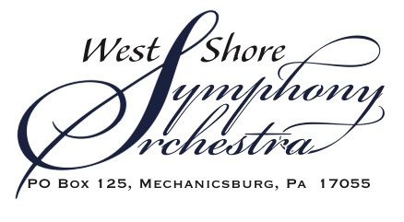

Concert Sponsorship
Please return to: PO Box 125, Mechanicsburg, PA, 17055

Organization Name: _______________________________________________________

Contact Name: __________________________________________________________

Address: ________________________________________________________________

City, State, Zip Code: ______________________________________________________

Email Address: _____________________________Phone: ________________________

Communications Coordinator Name and Email Address:
________________________________________________________________________

(Please check selected sponsorship)
________ MAESTRO CIRCLE – MASTERWORKS SERIES - $3,500
________ SUMMER SERIES – UP TO FOUR SUMMER CONCERTS - $2,500

________ CONCERTMASTER - $1,500 – Sponsor of one concert of your choice
____ November 5 ___March 3 ____ May 19 _____ Summer Concert 1, 2, 3, or 4

________ PRINCIPAL CHAIR - $1,000 - Sponsor of one concert of your choice
____ November 5 ___March 3 ____ May 19 _____ Summer Concert 1, 2, 3, or 4

________ SOLOIST - $750 - Sponsor of one concert of your choice
____ November 5 ___March 3 ____ May 19 _____ Summer Concert 1, 2, 3, or 4

________ MUSICIAN - $500 - Sponsor of one concert of your choice
____ November 5 ___March 3 ____ May 19 _____ Summer Concert 1, 2, 3, or 4

________ FAMILY CONCERT DRAMA (Contact manager@westshoresymphony.org)

_____ Check is enclosed _____ Please send an invoice to: (if different than above information)

Name:____________________________________________________________________

Address:__________________________________________________________________

City, State, Zip Code: _______________________________________________________

Phone: ______________ Email Address: _______________________________________

