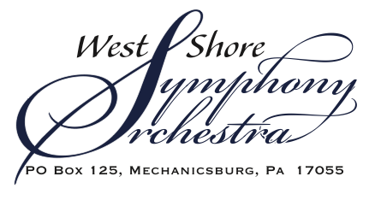

Dear Symphony Supporter,
The West Shore Symphony Orchestra (WSSO) offers an opportunity for you to become a Concert Sponsor for our 38th Anniversary Season! Under Conductor and Music Director, Dr. Jennifer Sacher Wiley, we will perform our Masterworks Concerts on November 2nd, March 1st, and May 2nd and our free Educational/Family Concerts on December 12th and 13th.
By sponsoring one or more of our concerts, you will help to ensure the ongoing success of the orchestra. Arts organizations such as WSSO depend on donors like you to continue offering affordable events to the community. Our Masterworks admission ticket of $15.00 as well as our free Family and Summer programming allow many members of the community to attend WSSO concerts more easily.
The orchestra presents three Masterworks Concerts per year, one scripted Educational Concert for school students, one Family Concert, and up to four Summer Concerts. Our Masterworks Concerts are our traditional concerts where great classical music is presented in a formal setting. WSSO also will be presenting a scripted Educational Concert to school-aged children as a field trip experience entitled “Vacation With The Orchestra.” Our free Family Concert is an extension of our Educational Concert and is open to the public. Our free Summer Concerts are offered in a variety of outdoor community spaces which feature a mix of classical, popular, and patriotic music. To learn more about the orchestra, we invite you to view our website at www.westshoresymphony.org.
We hope you will consider one of our affordable Concert Sponsorships (beginning at $500) or our Educational/Family/Summer Series Sponsorships (beginning at $1000.) We are pleased to continue our Maestro Circle Sponsorship ($3500+) for the most exposure. Benefits associated with Maestro Circle sponsorship include:
- Recognition as Sponsor at all three Masterworks Concerts
- Social media coverage
- Full page color ad in each of the three Masterworks Concert programs

WSSO would be pleased to partner with your organization at any level of support. We are also able to discuss customized sponsorships of our Family/Educational Concerts. Please find the enclosed form for additional levels of support.
Please feel free to contact me if you have any questions.
Listen Fresh, Listen Local TM, The West Shore Symphony Orchestra
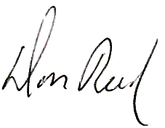
Don Reed, President
West Shore Symphony Orchestra
Email: president@westshoresymphony.org
Cell: 717-599-4091
