Fela Sowande Folk Symphony
Mood Outline, Dramatic Readings, Cuts

Introductory Reading

1960 was an important year in Nigeria, a time when the country declared its independence from Great Britain, after nearly 100 years of colonial rule. 55-year-old composer Fela Sowande, who had recently returned to his native Nigeria after having studied and worked in London, was asked to help select a National Anthem for his new nation. The Nigerian government also commissioned Chief Sowande to compose a new orchestral work commemorating its independence. The result of that commission is “A Folk Symphony” which we are about to perform.

Since that optimistic year of 1960, Nigeria, a country roughly the length of Massachusetts to South Carolina and width of New York to Ohio, has experienced: a Civil War, times of economic potential, the exploitation of natural resources, insurgency and violent religious struggles, the development of space exploration programs, an Ebola epidemic, recession, political corruption and military coups, the development of a new currency, new states and a relocation of the nation’s capital, the assassinations and executions of government leaders, food shortages, the creation of a continent-wide cultural festival, the rising and falling of democratic governments, global athletic triumphs and a Nobel Prize.

As current national and world events unfold at rapid pace, we offer these readings of Nigerian poets, novelists, biographers, playwrights and leaders spanning the 18th century to today. Sowande’s music stands as a moment-in-time work imbued with hope, celebration, and folk nostalgia. Our readings expand that viewpoint, highlighting a few more significant Nigerian voices and historical events. We believe this will enhance your experience of Sowande’s Folk Symphony, and provide an opportunity to consider citizens’ and artists’ responses to the winds of change.

First Movement, “Allegro Moderato”

Introduction: Organic, primordial folk beginnings, fermata

(over music) The ancient landscape of Nigeria varied from volcanos to sedimentary rock basins along its three large rivers. Great mammals such as antelope and Barbary sheep were in abundance. What began as individual human endeavors of survival flourished into diverse kingdoms of the Iron age. These sophisticated peoples were farmers, blacksmiths and artisans.

1:05 Lonely viola section solo: Main symphonic thematic material
1:36 Blooms into romantic song, (2:01) becomes Hollywood moment
stop at 2:25, before EH solo

People developed belief systems to explain their origins and establish guiding principles of their cultures. One of these kingdoms that developed in southern Nigeria was the Yoruba people. Listen to one of the Yoruba creation stories:

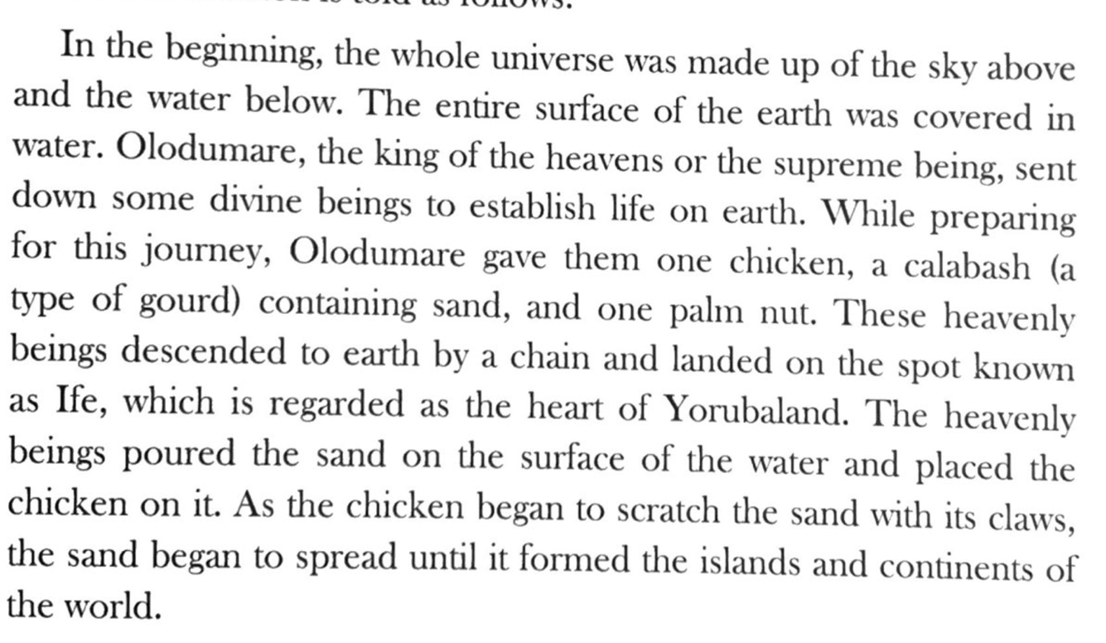

2:25 Nigerian introspective dance (Reh B)
3:40 Second Romantic tune (Reh C): Secondary symphonic thematic material
Stop at 4:14, after oboe solo

The optimism of Nigeria’s independence was short-lived. Cultural tensions resulted in a 3-year civil war from 1967-1970. This1967 poem by 91-year-old Nigerian writer Wole Soyinka, reflects the sorrow and anguish of that turbulent time:
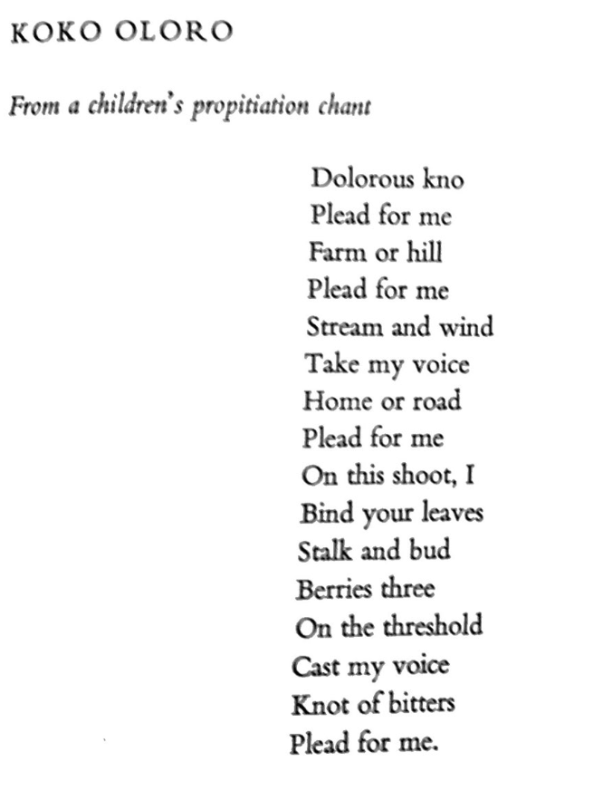

(4:18) Lonely viola /cello solo
(4:50) Blooms into romantic song, (5:13) becomes Hollywood moment
(5:53) Nigerian introspective dance (Reh F)
(7:29) Second Romantic tune (Reh G)
Fades sweetly

Here is another poem by Wole Soyinka, with a contrasting mood in anticipation of Sowande’s joyful 2nd movement: “Her Joy is Wild”

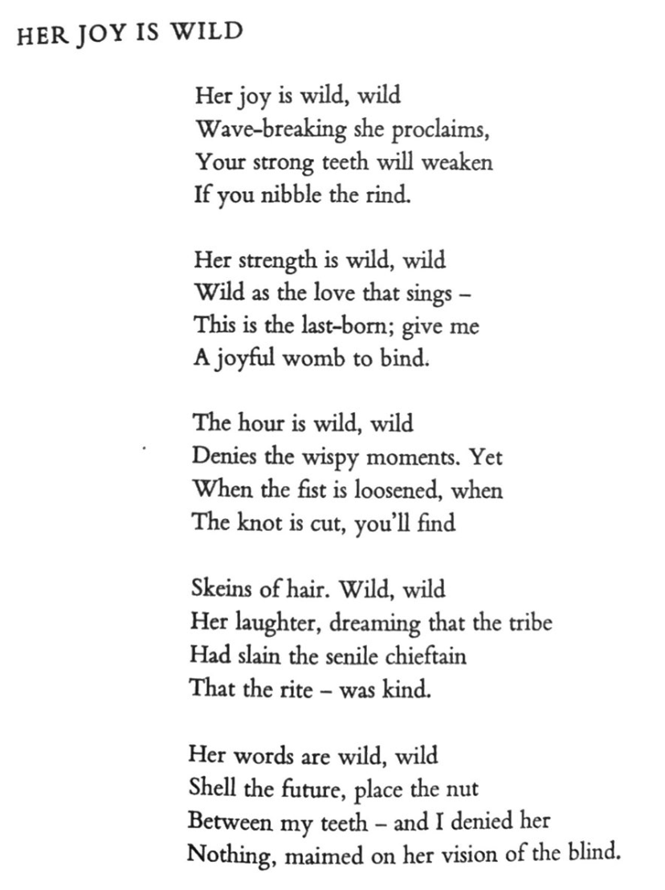

Second Movement, “Vivace”

CUT: Start at Reh B
Vigorous fun Nigerian dance (C major)
Stop before suspenseful moment (:28)

A distinctive musical moment is about to occur in this symphony. Sowande composed an agitated sounding transition which results in a rollicking meter that evokes the sea. For 350 years, the Atlantic Ocean was the scene of the humanitarian violation known as the Triangle Slave Trade, a practice that fed the global economies of Europe, Africa, and North America. We will now share an excerpt from the memoir of Olaudah Equiano who was born into the Ibo tribe of Isseke, Nigeria in 1745 and captured for slavery at the age of eleven. The reading begins after having spent time as a slave of several masters throughout western Africa, finally arriving at the ocean:

(p. 53)
“At the end of six or seven months after having been kidnapped, I arrived at the sea coast. The first object which saluted my eyes was the sea, and a slave ship, which was riding at anchor, and waiting for its cargo. These filled me with astonishment, which was soon converted into terror, when I was carried on board. I was now persuaded that I had gotten into a world of bad spirits, and that they were going to kill me. (p 54) Quite overpowered with horror and anguish, I fell motionless on the deck and fainted. I now saw myself deprived of all chance of returning to my native country. I was soon put down under the decks, and there I received such a salutation in my nostrils as I had never experienced in my life. On my refusing to eat, one white man tied my feet while the other flogged me severely. (p 54) I later found some of my own nation who gave me to understand, we were to be carried to these white people’s country to work for them. (p. 56) Every circumstance I met with on board heightened my opinion of the cruelty of the whites. One day they had taken a number of fishes, and when they had satisfied themselves with as many as they thought fit, to our astonishment, rather than give any of them to us to eat, they tossed the remaining fish into the sea again, although we begged and prayed for some. (p. 57) One day, two of my wearied countrymen who were chained together, somehow made through the nettings and jumped into the sea, preferring death to such a life of misery. At last we came to the island of Barbados,”

(:29) Transition, becomes agitated
(:38) Despairing dance in a minor
(1:20) Transition
Stop at 1:42

The music comes to a resting place, as a ship might arrive at a port. This excerpt from the play “Parables for a Season” by Tess Akaeke Onwueme was chosen for its consistent reference to soil and civic responsibility. It takes place in a fictitious kingdom where a new democracy is forming.
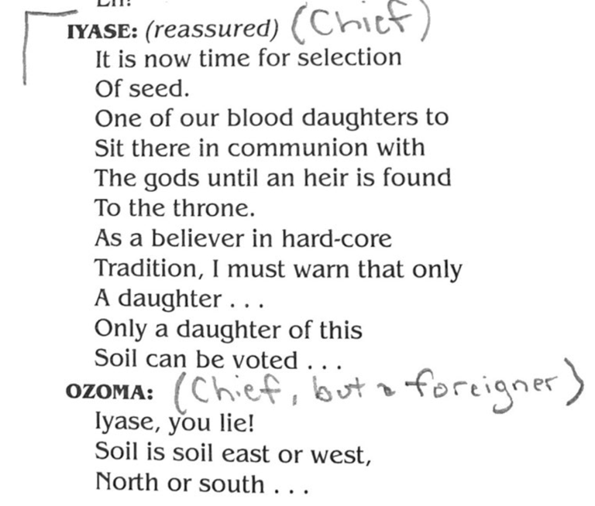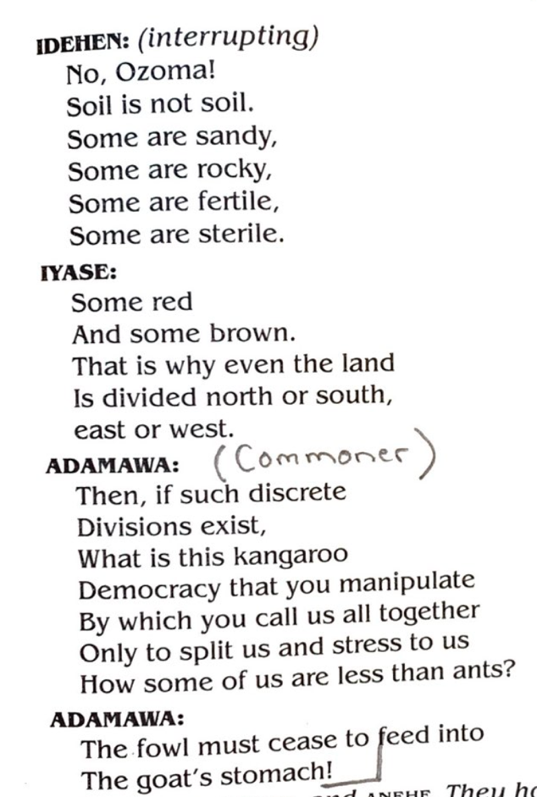

(1:43) Calm sea, becomes a more grand waltz (2:31)
(3:27) Vigorous fun Nigerian dance
(3:53) Dance becomes more wild, fun climactic ending in C major

Nigerian writer Sayo Okpaise wrote this poem as part of her 2019 memoir “I am Nigerian, you might be too”

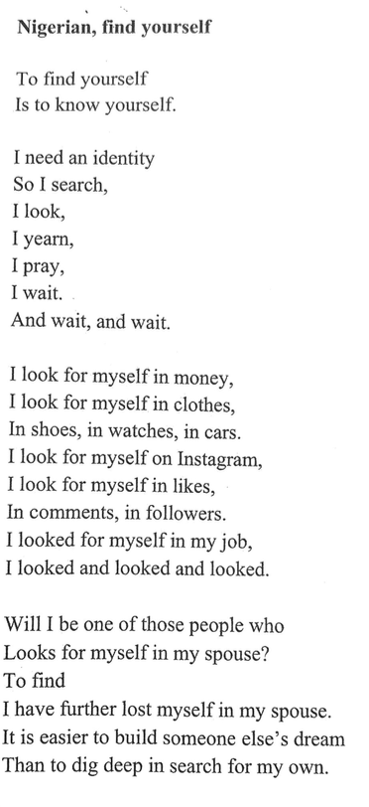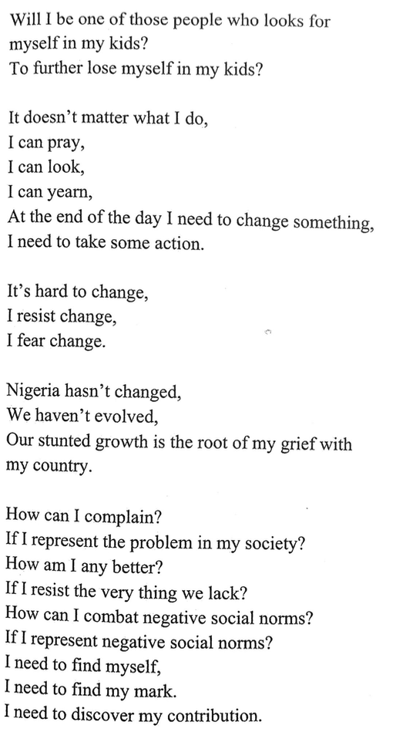

Third movement, “Andante con moto”

Calm sea theme becomes an aria
(:40) Transition becomes dense with triplets (problem solving)
Clears with bucolic flute song (1:15)
Stop at (1:32)
“We offer another poem by Miss Okpaise, followed by a poignant moment in our symphony: a mournful melody played by the English horn. Sayo Okpaise reflects about the future of her country “In Nigeria, there will always be something”

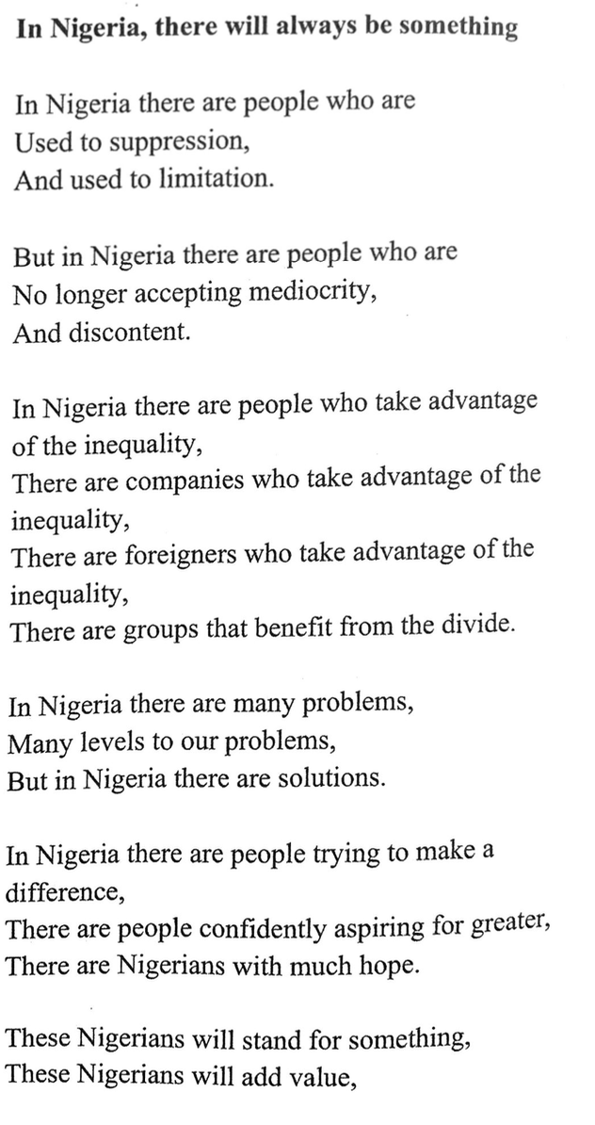
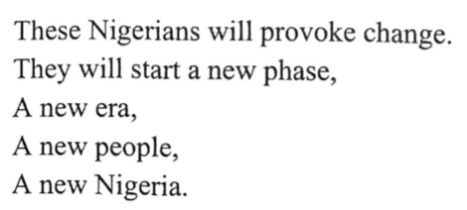

Mournful mountain song (Reh D) (1:34)
Clears with bucolic flute song transition (3:17)
Calm sea theme as 4/4 aria (3:35)
Transition becomes dense with triplets (4:08)
Ends sweetly

“Rain Coming by Niyi Osundare, 1986”

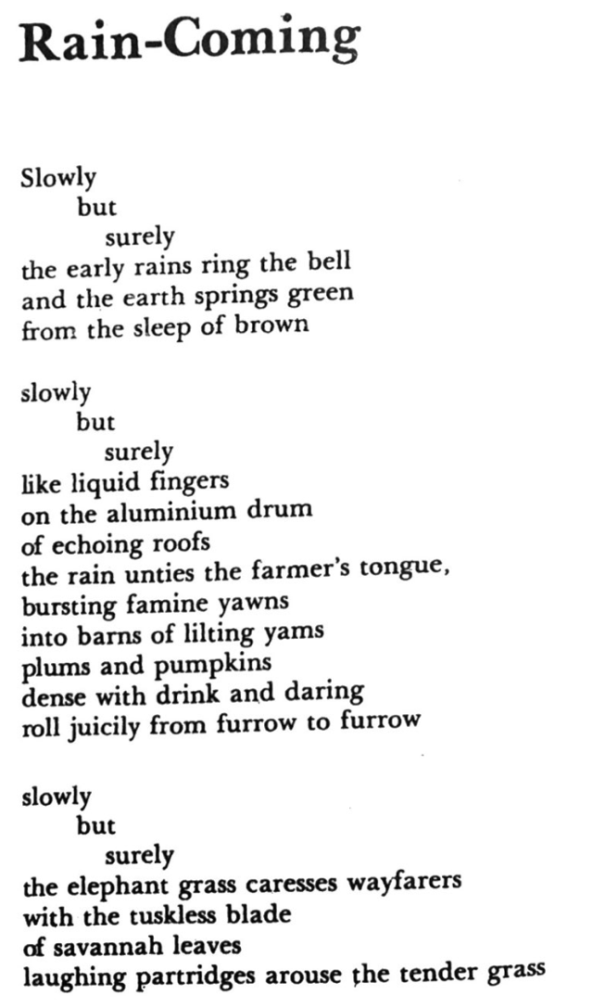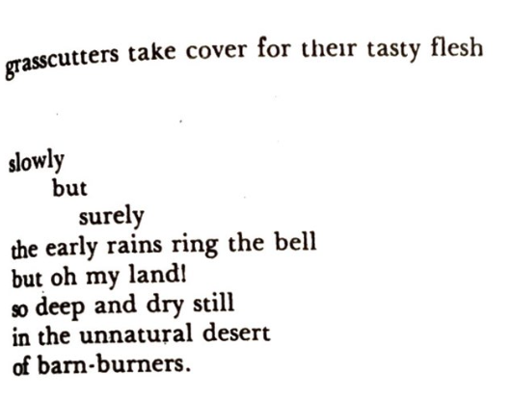

Fourth movement, “Allegro con moto”

Perky Nigerian folk song: “Calm sea” theme transformed (D major)
Transition (:36)
Climactic joy (“Allegro assai” m. 28) (:58)
Transition more intense: Brass “Calm sea” theme transformed to proud statement (1:14)
Stop at 1:42

The King’s Magic Drum
A Nigerian Fable

Narrator: Calabar is a city in southern Nigeria, near the Gulf of Guinnea. Long ago, an ancient and peaceful king of Calabar, named Efriam Duke, owned a wonderful drum. Whenever the drum was beaten, plenty of good food and drink magically appeared.

Narrator: One drawback to the drum: if its owner walked over a stick or branch, all of the food would instantly spoil and no more fresh food could satisfy the drum owner or their friends.

Narrator: Another drawback to the drum: many people and even animals in the kingdom were envious of the drum and sought to posses it. King Efriam held fast to his own treasure, rarely allowing it out of his sight.

Narrator: One morning, one of King Efriam’s wives, named Ikwor, went to the local stream to give her daughter a bath. The tortoise was climbing in a palm tree, cutting nuts for his midday meal. One of the nuts fell to the ground. Ikwor gave the nut to her daughter. The tortoise thought of a way to trick Ikwor and King Efriam into giving him his magical drum.

Tortoise: I am a poor tortoise, foraging for nuts for my family. You took one of my fallen palm nuts and gave it to your child. I shall tell King Efriam about how you stole from me.
Ikwor Edem: I promise I didn’t steal it! I didn’t realize it belonged to you. We will ask the king for a gift to show you how sorry we are.

Ikwor (bowing to King, with Tortoise nearby): My husband, I accidentally took one of Tortoise’s palm nuts and he is angry. Would you offer him compensation for my wrong doing?
King Efriam: Certainly, Tortoise. Can I offer you some gold coins?
Tortoise: I do not want coins.
King Efriam: How about some of this fine cloth?
Tortoise: I do not want your cloth.
King Efriam: Kernels? Palm Oil?
Tortoise: No. No.
King Efriam: Anything, then. Take anything you like.
Tortoise: I would like your drum.
King Efriam (sighing): Very well, take the drum.

Narrator: King Efriam had not warned him not to step over sticks or branches. But the tortoise, oblivious to the danger of the drum, triumphantly carried the drum home.

Tortoise: I am now a rich man, and shall do no more work. Whenever I want food, all I have to do is beat this drum and food & drink shall appear.

Narrator: And so, the tortoise was able to feed his family easily. As time went on, the tortoise became lazy and starting to drink throughout the day. One day he stepped over a stick on his way home, breaking the magic of the drum.

Tortoise’s wife: Your children and I are hungry!
Tortoise: Don’t look at me- the drum has stopped working!
Tortoise’s wife: Go back to the king and demand an explanation!

Narrator: The tortoise started to walk back to the King’s palace, but became so tired from his drinking and laziness that he fell asleep under a prickly palm tree. His wife and family eventually found him there and stayed with him, and this is where tortoises can be found to this day, longing for their magic drum but eating what they can find under palm trees instead.

Nigerian jazzy dance (1:44)
(2:49) Transition, texture thins, percussion stops (m. 82), (3:12) becomes sweeter
(Over music): “In his 1960 maiden speech as Prime Minister of a now independent Nigeria, Abubakar Tafawa Balewa said”

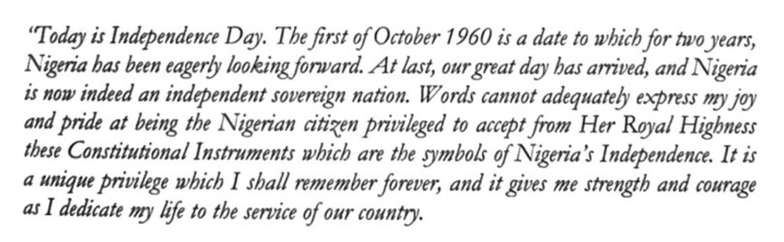

Development of themes & transition
(3:53) Perky Nigerian folk song: “Calm sea” theme transformed
Transition (4:29)
Climactic joy (4:50)
Transition more intense: Brass “Calm sea” theme transformed to proud statement (5:06)

Nigerian jazzy dance (Reh E) (5:35)
Coda at Reh F: Exuberant and a bit frenzied (6:25)
Triplet transition (7:25)
VAMP (7:30)
(over vamp):
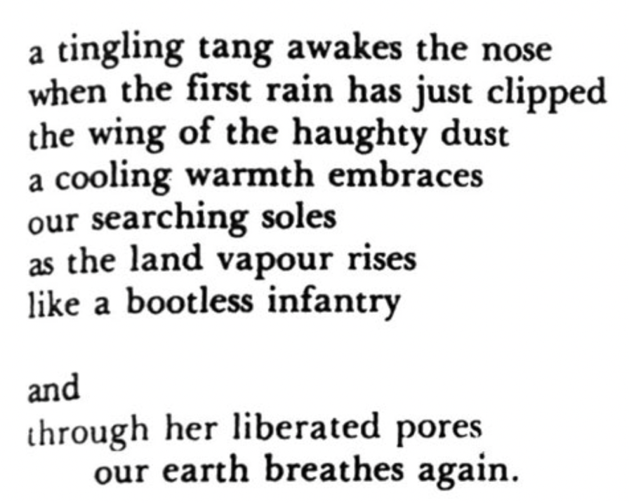

Second Romantic tune from 1st movement: Hope theme (7:41)
Piece concludes

